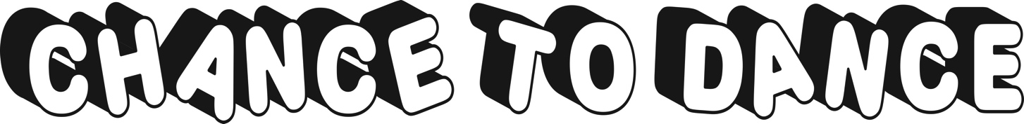
140 North Belle Mead Rd Suite F Setauket, NY 11733 Chance2dance@aol.com

2018 ADULT Summer Session

6 Week Summer Session
Tuesday July 17th, 24th, 31st, August 7th, 14th, 21st

- Zumba 5:30-6:15pm $50
- Yoga 8:30-9:15pm $50
- Both Zumba and Yoga $75

____________________________________________________________________________________________

To register, please mail this form to Chance To Dance with full payment.
Classes Must Have 6 Students Enrolled 2 Weeks Prior To Start Date To Remain Open

Name_______________________________________________________________________________________________________
Address_____________________________________________________________________________________________________
City_________________________________________________________________Zip____________________________________
E-Mail Address_______________________________________________________________________________________________
Phone Number__________________________________ Cell Phone Number _____________________________________________
Birthday (Year Not Needed)_____________________________ Dance Experience_________________________________________

Feel free to contact Miss Jen via email with any questions at: Chance2dance@aol.com

